Human Activity Recognition

* Introduction

Human activity recognition plays a significant role in human-to-human interaction and interpersonal relations. Because it provides information about the identity of a person, their personality, and psychological state, it is difficult to extract. The human ability to recognize another person’s activities is one of the main subjects of study of the scientific areas of computer vision and machine learning. As a result of this research, many applications, including video surveillance systems, human-computer interaction, and robotics for human behavior characterization, require a multiple activity recognition system.

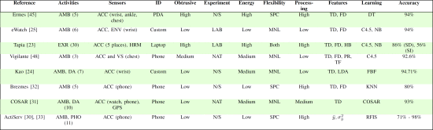

Summary of state-of-the-art in online human activity recognition systems.

* Model

Deep Neural Network (DNN), Convolutional Neural Network (CNN), Recurrent Neural Network (RNN), Deep Belief Network (DBN), Stacked Auto encoder (SAE), and Hybrid Models.

* Dataset

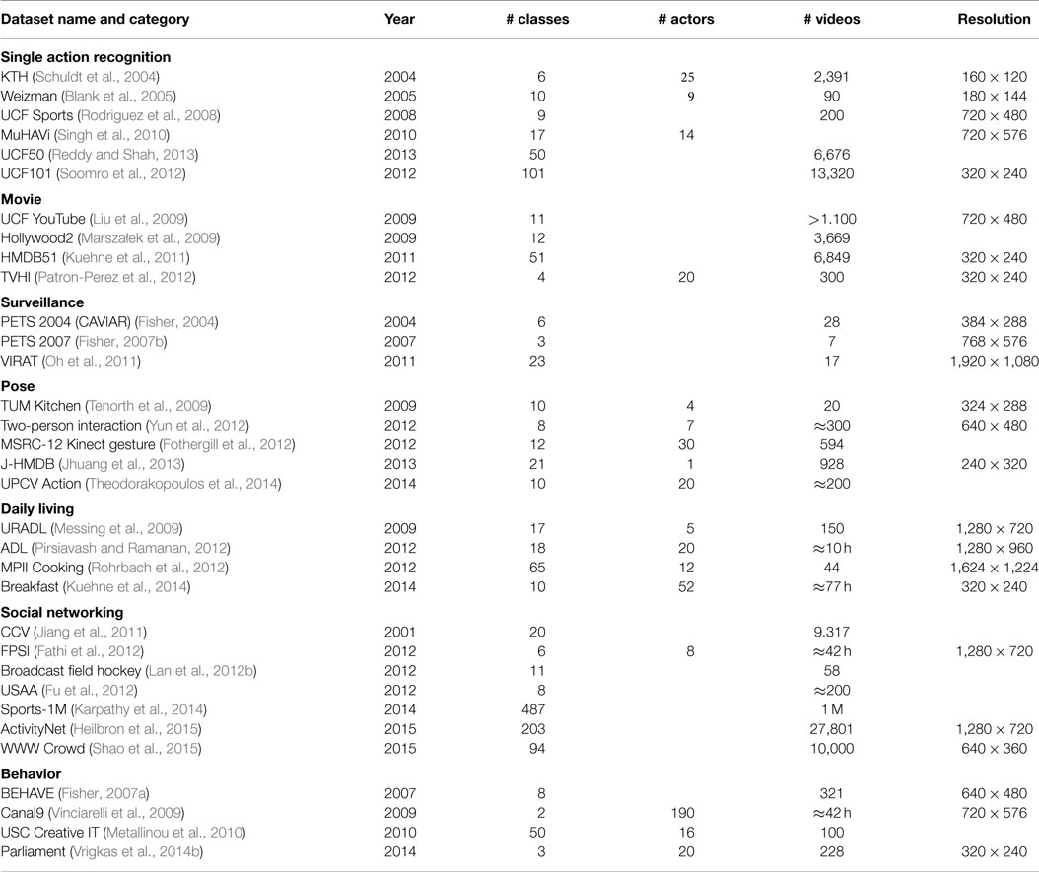

* Plan

In my project, I plan to use CNN model and UCI-HAR Date.



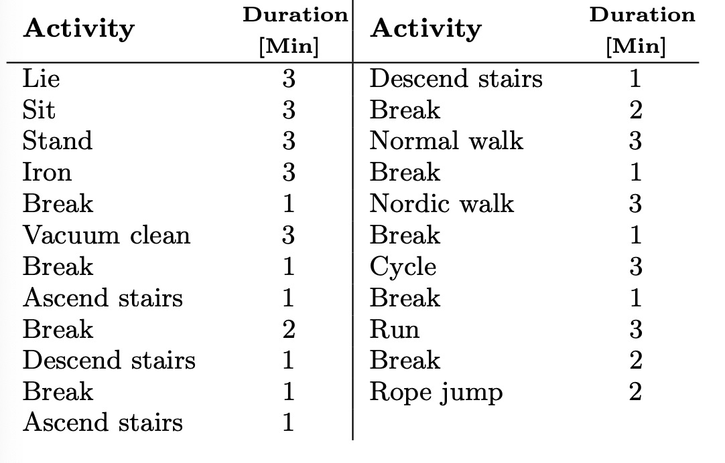

In my project, my task is to collect human activity data through mobile devices and analyze the collected data.According to the analysis, the intensity of human activity was identified.In HAR, CNN offers two major benefits over other models: local dependency and scale invariance. CNNs possess a better capability of inferring repetitive.Convolutional neural network (CNN) and temporal fast Fourier transform are combined in whereas CNN along with statistical features and data centering is shown to classify human actions with high accuracy in.

Reference

Shuvo, M. M. H., Ahmed, N., Nouduri, K., & Palaniappan, K. (2020, October). A Hybrid Approach for Human Activity Recognition with Support Vector Machine and 1D Convolutional Neural Network. In 2020 IEEE Applied Imagery Pattern Recognition Workshop (AIPR) (pp. 1-5). IEEE.

Lee, S. M., Yoon, S. M., & Cho, H. (2017, February). Human activity recognition from accelerometer data using Convolutional Neural Network. In 2017 ieee international conference on big data and smart computing (bigcomp) (pp. 131-134). IEEE.

Vrigkas, M., Nikou, C., & Kakadiaris, I. A. (2015). A review of human activity recognition methods. Frontiers in Robotics and AI, 2, 28.